Proposed Modification to Distribution Factor Calculations

We were recently presented with the case of a box girder bridge with a wide sidewalk as seen in Figure 1.
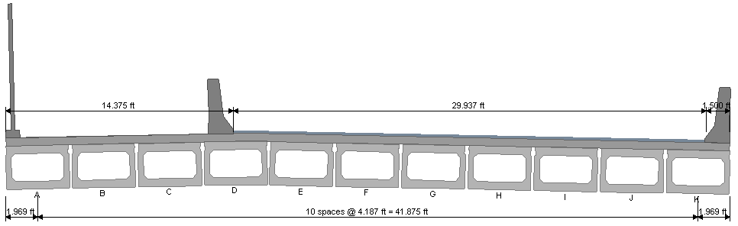
Figure 1

The live load distribution factors computed by PGSuper appear to be, for all intents and purposes, incorrect. This stems from the fact that the parameter d_{e} is approximately -14 ft.

While technically, this is correct for a Type (f) cross section it does lead to numerical problems in the calculations. Specifically, when computing shearing in the exterior beam (Girder A) a square root of a negative value is taken when computing the parameter e. Obviously this is not correct.

It should be assumed that the sidewalk and combination railing will be removed for some future bridge configuration and that traffic will be over Girder A. For this configuration, d_{e} should always be based on the exterior barrier.

